better-investing

](https://www.betterinvesting.org/chapters/georgia/local-events)

Georgia Chapter September Bulletin

[**Upcoming Events**](https://www.betterinvesting.org/chapters/georgia/local-events)

Thursday, September 12th, 7:00 PM ET: Monthly Mentoring

The Monthly Mentoring Sessions are held every 2nd Thursday of the month and are open to all Georgia Chapter Clubs and Members.

This is your opportunity to get your questions answered. No agenda, you control the discussion.

**Register For Mentoring Here:** [REGISTER HERE](https://register.gotowebinar.com/register/5069410944960845149)

Saturday, September 14th, 12:00 PM ET: ACME Model Investment Club

The ACME club meets on the 2nd Saturday of the month at noon. All are welcome to come and learn about investing with us.

**Join The Meeting Here:** <https://global.gotomeeting.com/join/594493789>

Saturday, September 21st, 12:00 PM ET: Central Georgia Model Investment Club (CGMIC) Meeting

CGMIC meets monthly on the 3rd Saturday at noon. Meetings are free and open to the public.

**Join The Meeting Here**: <https://global.gotomeeting.com/join/735717165>

[Keep Up With All The Latest Georgia Chapter Events Here](https://www.betterinvesting.org/chapters/georgia/local-events)

**Investors Education Fair**

That’s a wrap! The Georgia Chapter concluded its 10th Annual Investor Education Fair Saturday, August 24th. Thank you to all our wonderful participants who logged on from across Georgia and the southeast. And a big thank you to our fantastic presenters who provided so many insightful and interesting classes and helped to make this year’s education fair our best event yet.

Make sure to mark your calendars for next year and join us in person Saturday, August 23, 2025 for the next education fair!

**Monthly Mentoring Series**

](https://www.betterinvesting.org/chapters/georgia/local-events/club-and-individual-august)

Monthly Mentoring returns Thursday, September 12th at 7:00 PM ET. What’s a little healthy competition? This month, Director Kyra discusses company peers and competition on the SSG. Competition can make your SSG a winner!

Join us on the 2nd Thursday at 7:00 PM ET for an in-depth look into different aspects of the SSG. Have questions? Get them answered here!

[REGISTER HERE](https://attendee.gotowebinar.com/register/5069410944960845149) to be an SSG insider.

**Portfolio Contest**

[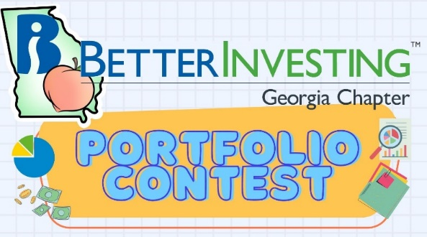](https://www.betterinvesting.org/chapters/georgia/news-articles)

The 2024 Portfolio Contest is in the final stretch! We provide portfolio performance updates each month during our Monthly Mentoring sessions, every 2nd Thursday of the month.

The contest continues until December when the winning portfolio will be announced. The investments are imaginary, but the prizes are real!

Want to learn more? Check out all the details on our [Webpage](https://www.betterinvesting.org/chapters/georgia/news-articles).

**Contacts**

Chapter Email: [contact@georgia.betterinvesting.net](mailto:contact@georgia.betterinvesting.net)

Chapter Webpage: [www.betterinvesting.org/georgia](http://www.betterinvesting.org/georgia)

Follow Us On Facebook: [www.facebook.com/betterinvestinggeorgiachapter](http://www.facebook.com/betterinvestinggeorgiachapter)

Join Us On Meetup: [https://www.meetup.com/bigachapter](https://na01.safelinks.protection.outlook.com/?url=https%3A%2F%2Flists.betterinvesting.org%2Flink.php%3FM%3D1786145%26N%3D26166%26L%3D15619%26F%3DH&data=05%7C01%7C%7C837e11ba7e2f4ff7906d08db94117bbf%7C84df9e7fe9f640afb435aaaaaaaaaaaa%7C1%7C0%7C638266575040350710%7CUnknown%7CTWFpbGZsb3d8eyJWIjoiMC4wLjAwMDAiLCJQIjoiV2luMzIiLCJBTiI6Ik1haWwiLCJXVCI6Mn0%3D%7C3000%7C%7C%7C&sdata=w6mbsV55ShlnBNxaepfTqs2i4DX5TaMVUAxX%2Bfkbk9k%3D&reserved=0)

**Share This Newsletter**

Would you or someone you know benefit from receiving timely news about investing education programs?

Forward this newsletter!

And be sure to get all the great information we send out by signing up on our webpage [HERE](https://www.betterinvesting.org/chapters/georgia)