better-investing

Georgia Chapter December Bulletin



**Upcoming Events**

Saturday, December 14th, 12:00 PM ET: ACME Model Investment Club

The ACME club meets on the 2nd Saturday of the month at noon. All are welcome to come and learn about investing with us.

**Join The Meeting Here**: <https://global.gotomeeting.com/join/594493789>

Saturday, December 21st, 12:00 PM ET: Central Georgia Model Investment Club (CGMIC) Meeting

CGMIC meets monthly on the 3rd Saturday at noon. Meetings are free and open to the public.

**Join The Meeting Here:** <https://global.gotomeeting.com/join/735717165>

[Keep Up With All The Latest Georgia Chapter Events Here](https://www.betterinvesting.org/chapters/georgia/local-events)

**Monthly Mentoring Series**

No Monthly Mentoring session for December! We wish all our members a wonderful holiday season and look forward to returning to mentoring in the new year.

Monthly Mentoring will be back in 2025! Join us every month on the 2nd Thursday at 7:00 PM ET for an in-depth look into different aspects of the SSG. Have questions? Get them answered here!

Stay in the know on all our mentoring events [HERE](https://www.betterinvesting.org/chapters/georgia/local-events).

Did you miss a session? Check out our previous Mentoring recordings here, <https://gotostage.com/channel/gachaptmentoring>

**Portfolio Contest 2024**

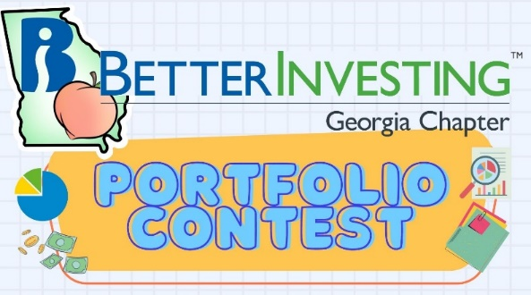

The 2024 Georgia Chapter Portfolio Contest is in its final month!

The contest continues until December 29th, when the winning portfolio will be announced.

Want to learn more? Check out all the details on our [Webpage](https://www.betterinvesting.org/chapters/georgia/news-articles).

Did you miss out on the portfolio contest this year? Join us for the portfolio contest 2025! It seems that members of our chapter were reluctant to show off their investing skills, we only had five individual entries and three club entries. I know we can do better than that!

Remember, you don’t have to enter your actual portfolio. You can make up a watchlist portfolio or just a list of companies that you are interested in.

This is intended as a fun exercise for all. Check out the rules and the entry form on the [chapter website](https://www.betterinvesting.org/chapters/georgia/news-articles) and let’s have some fun! If you enter, you may end up with a little money in your pocket. Remember, the portfolios might be imaginary, but the prizes are real!

We hope to receive your entry form soon and

Good luck and BetterInvesting!

**Contacts**

Chapter Email: [contact@georgia.betterinvesting.net](mailto:contact@georgia.betterinvesting.net)

Chapter Webpage: [www.betterinvesting.org/georgia](http://www.betterinvesting.org/georgia)

Follow Us On Facebook: [www.facebook.com/betterinvestinggeorgiachapter](http://www.facebook.com/betterinvestinggeorgiachapter)

Join Us On Meetup: [https://www.meetup.com/bigachapter](https://na01.safelinks.protection.outlook.com/?url=https%3A%2F%2Flists.betterinvesting.org%2Flink.php%3FM%3D1786145%26N%3D26166%26L%3D15619%26F%3DH&data=05%7C01%7C%7C837e11ba7e2f4ff7906d08db94117bbf%7C84df9e7fe9f640afb435aaaaaaaaaaaa%7C1%7C0%7C638266575040350710%7CUnknown%7CTWFpbGZsb3d8eyJWIjoiMC4wLjAwMDAiLCJQIjoiV2luMzIiLCJBTiI6Ik1haWwiLCJXVCI6Mn0%3D%7C3000%7C%7C%7C&sdata=w6mbsV55ShlnBNxaepfTqs2i4DX5TaMVUAxX%2Bfkbk9k%3D&reserved=0)



**Share This Newsletter**

Would you or someone you know benefit from receiving timely news about investing education programs?

Forward this newsletter!

And be sure to get all the great information we send out by signing up on our webpage [HERE](https://www.betterinvesting.org/chapters/georgia).

