better-investing

Georgia Chapter January Bulletin



**Upcoming Events**

Thursday, January 9th, 7:00 PM ET: Monthly Mentoring

The Monthly Mentoring Sessions are held every 2nd Thursday of the month and are open to all Georgia Chapter Clubs and Members. This is your opportunity to get your questions answered. No agenda, you control the discussion.

**Register For Mentoring Here:** [REGISTER HERE](https://attendee.gotowebinar.com/register/3296493531289169498)

Saturday, January 11th, 12:00 PM ET: ACME Model Investment Club

The ACME club meets on the 2nd Saturday of the month at noon. All are welcome to come and learn about investing with us.

**Join The Meeting Here**: <https://global.gotomeeting.com/join/594493789>

Saturday, January 18th, 12:00 PM ET: Central Georgia Model Investment Club (CGMIC) Meeting

CGMIC meets monthly on the 3rd Saturday at noon. Meetings are free and open to the public.

**Join The Meeting Here:** <https://global.gotomeeting.com/join/735717165>

[Keep Up With All The Latest Georgia Chapter Events Here](https://www.betterinvesting.org/chapters/georgia/local-events)

**Monthly Mentoring Series**

](https://attendee.gotowebinar.com/register/3296493531289169498)

Monthly Mentoring is back in 2025!

This month Director Liz will kick off the new year with a look at the First Cut Report for Novo Nordisk (NVO). You can create your own SSG and First Cut for NVO and follow along as Liz discusses the process for completing an SSG and First Cut.

Join us every month on the 2nd Thursday at 7:00 PM ET for an in-depth look into different aspects of the SSG. Have questions? Get them answered here!

[REGISTER HERE](https://attendee.gotowebinar.com/register/3296493531289169498) to be an SSG insider.

Did you miss a session? Check out our previous Mentoring recordings here: <https://gotostage.com/channel/gachaptmentoring>

**Portfolio Contest**

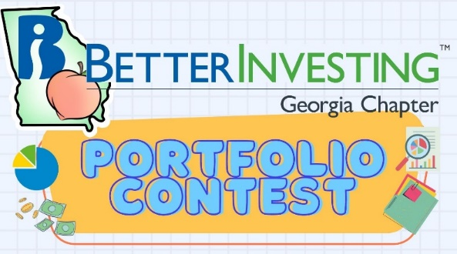

That’s a wrap for the 2024 Portfolio Contest!

We will be announcing the winners soon and thank you to all who participated. Well Done!

Did you miss out on the portfolio contest deadline, but still want to join in on the fun? Be sure to follow along with our portfolio hopefuls this year. Contest progress is updated every month during our Monthly Mentoring Series.

Want to learn more? Check out all the details on our [Webpage](https://www.betterinvesting.org/chapters/georgia/news-articles).

**Contacts**

Chapter Email: [contact@georgia.betterinvesting.net](mailto:contact@georgia.betterinvesting.net)

Chapter Webpage: [www.betterinvesting.org/georgia](http://www.betterinvesting.org/georgia)

Follow Us On Facebook: [www.facebook.com/betterinvestinggeorgiachapter](http://www.facebook.com/betterinvestinggeorgiachapter)

Join Us On Meetup: [https://www.meetup.com/bigachapter](https://na01.safelinks.protection.outlook.com/?url=https%3A%2F%2Flists.betterinvesting.org%2Flink.php%3FM%3D1786145%26N%3D26166%26L%3D15619%26F%3DH&data=05%7C01%7C%7C837e11ba7e2f4ff7906d08db94117bbf%7C84df9e7fe9f640afb435aaaaaaaaaaaa%7C1%7C0%7C638266575040350710%7CUnknown%7CTWFpbGZsb3d8eyJWIjoiMC4wLjAwMDAiLCJQIjoiV2luMzIiLCJBTiI6Ik1haWwiLCJXVCI6Mn0%3D%7C3000%7C%7C%7C&sdata=w6mbsV55ShlnBNxaepfTqs2i4DX5TaMVUAxX%2Bfkbk9k%3D&reserved=0)

**Share This Newsletter**

Would you or someone you know benefit from receiving timely news about investing education programs?

Forward this newsletter!

And be sure to get all the great information we send out by signing up on our webpage [HERE](https://www.betterinvesting.org/chapters/georgia).

