Georgia Chapter July Bulletin

Upcoming Events

Thursday, July 11th, 7:00 PM ET: Monthly Mentoring
The Monthly Mentoring Sessions are held every 2nd Thursday of the month and are open to all Georgia Chapter Clubs and Members.
This is your opportunity to get your questions answered. No agenda, you control the discussion.
Register For Mentoring Here: REGISTER HERE

Saturday, July 13th, 12:00 PM ET: ACME Model Investment Club
The ACME club meets on the 2nd Saturday of the month at noon. All are welcome to come and learn about investing with us.
Join The Meeting Here: https://global.gotomeeting.com/join/594493789

Saturday, July 20th, 12:00 PM ET: Central Georgia Model Investment Club (CGMIC) Meeting
CGMIC meets monthly on the 3rd Saturday at noon. Meetings are free and open to the public.
Join The Meeting Here: https://global.gotomeeting.com/join/735717165

Saturday, July 27th, 2:00 PM ET: Georgia Chapter Annual Meeting
Fayette County Public Library, 1821 Heritage Park Way Fayetteville, GA 30214
Register For The Meeting Here: https://register.gotowebinar.com/register/1041109308623733077

Keep Up With All The Latest Georgia Chapter Events Here

Investors Education Fair
The Georgia Chapter Investors Education Fair returns for its 10th year on Saturday, August 24th! Join us virtually this year for outstanding classes taught by some of the best of the best in the BetterInvesting community. Stay tuned for all the updates and learn more on our webpage.

Monthly Mentoring Series
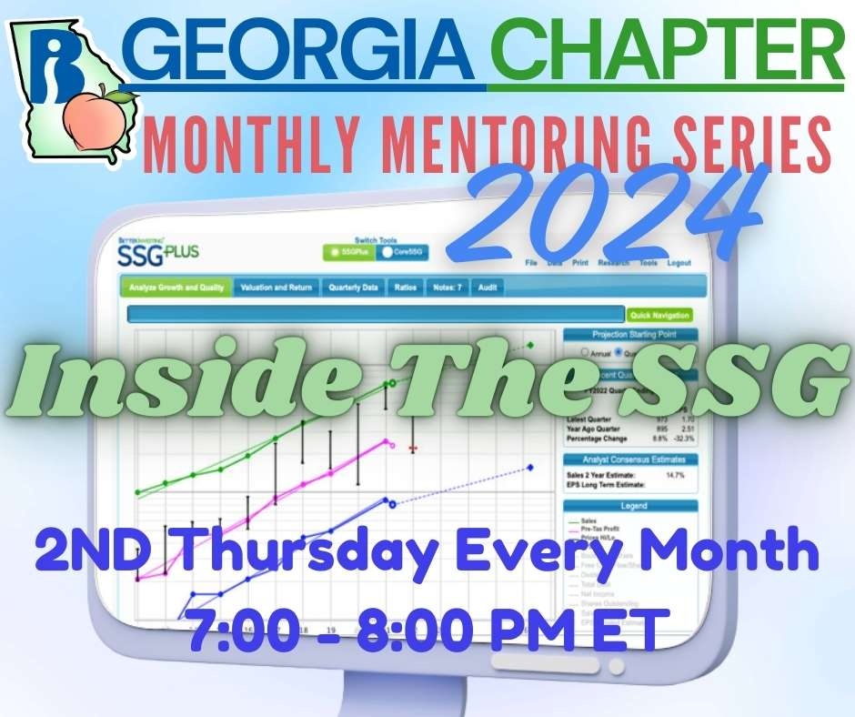
Monthly Mentoring is Thursday, July 11th at 7:00 PM ET. This month, Director Lindy discusses the Stock Comparison Guide. When comparing SSGs, do you choose door #1 or door #2? The SCG is here to help you make your decision!
Join us on the 2nd Thursday at 7:00 PM ET for an in-depth look into different aspects of the SSG. Have questions? Get them answered here!
REGISTER HERE to be an SSG insider.

Annual Meeting
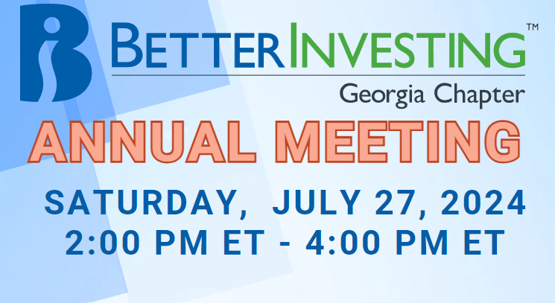
The Georgia Chapter holds its annual meeting Saturday, July 27th at 2:00 PM ET at the Fayette County Public Library. This is your opportunity to meet your Georgia Chapter board members! The meeting will be a review of last year’s activities and a preview of the upcoming year as well as elections for board members. Please join us online or in person at the Fayette County Public Library, 1821 Heritage Pkwy, Fayetteville, GA 30214.
Learn more and REGISTER HERE for this event on our Webpage.
Portfolio Contest
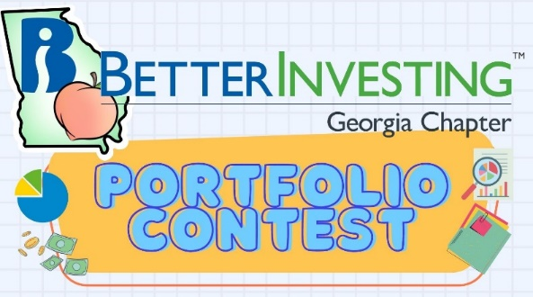
The 2024 Portfolio Contest is in the sizzlin’ summer stretch! We provide portfolio performance updates each month during our Monthly Mentoring sessions, every 2nd Thursday of the month.
The contest continues until December when the winning portfolio will be announced. The investments are imaginary, but the prizes are real!

Want to learn more? Check out all the details on our Webpage.

Contacts
Chapter Email: contact@georgia.betterinvesting.net
Chapter Webpage: www.betterinvesting.org/georgia
Follow Us On Facebook: www.facebook.com/betterinvestinggeorgiachapter
Join Us On Meetup: https://www.meetup.com/bigachapter
Share This Newsletter
Would you or someone you know benefit from receiving timely news about investing education programs?
Forward this newsletter!
And be sure to get all the great information we send out by signing up on our webpage HERE

